**Heart Failure Diseases Prediction**

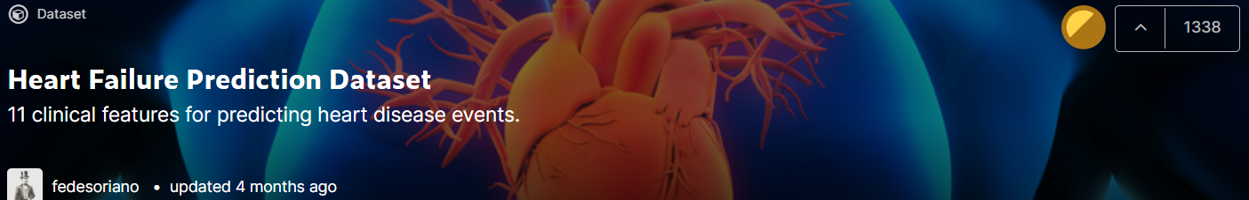

[Heart Failure Prediction Dataset | Kaggle](https://www.kaggle.com/fedesoriano/heart-failure-prediction/code)

Our team names:

ندي ايمن عبدالعزيز حسن نصر يمني عبدالمنعم حسني الغنام

عبير محمد فتحي المرشدي ندي ناصر بدوى احمد

In this project:

we want to predict whether the patient has heart failure or not.

Using some of the characteristics we took from a patient survey.

918 questionnaires were collected from patients and a predictor was made and used to detect this disease.

After applying this model, disease was predicted by 86% Accuracy.

Below is a detailed view of the steps we have taken:

**Steps**

1. Importing libraries
2. Import the dataset
3. Knowing information about dataset
4. Check for missing values
5. Cleaning dataset

* Check for missing values(what we just need)

1. See the categorical values
2. Visualizing dataset
3. Extracting Independent & dependent Variable
4. Encode the Categorical Variable
5. Using Feature selection technique [RFE]
6. Splitting the data-set (Training & Test Set)
7. Feature Scaling
8. Training Decision Tree Classifier
9. Comparing Results
10. Checking for Accuracy
11. Checking for overfitting
12. Importing libraries

We use these libraries:



1. Import the dataset

-We import our dataset which has 918 rows & 11 features.



3-Knowing information about dataset

-In this step, we know our features and their names, we also know which feature is important and which is not (for example, Age and sex is not very important )

-in this step, we also know our type of values (float, int , object[we must fix it in this project])

4-Check for missing values

-In this step, we are looking for if there are missing, error or non-existent values.

5-Cleaning dataset

-In this step , we just need to drop rows (3 rows) which have missing values to clean our dataset.

6-See the categorical values

-In this step, By using [.head()] method we can easily know our categorical values to can modify it later.

7-Visualizing dataset

-In this step , we are trying to show ranges of values for every features in our datasets (Not equal )

-This plot shows The number of those who were classified as sick(1) and the number of healthy ones(0).

8-Extracting Independent & dependent Variable

-In this step, we select our independent variable (all columns except the last one),and dependent one (last column).



9-Encode the Categorical Variable

-In this step, we modify our values of column [1,2,6,8,10],to turn them to numeric variables to can our model deal with them (we cannot do that if they were categoric ones ).

-we know show our new features, we notice that the 11 features turn into 20 features and their values are not equal (have not equal ranges of features)

10-Using Feature selection technique [RFE]

-In this step, we are trying to reduce our features from 20 to 5 features by identify which feature is more important rather than the others , we do this by Recursive Feature Elimination Technique.

-we can now see that our features reduced from 20 to just the most important 5 features which affect more in our prediction .

11-Splitting the dataset (Training & Test Set)

-In this step, we split our dataset to training and test dataset , as we training the model on (80%)of data and (20%) we test our model in them.

12-Feature Scaling

-In this step, as we saw our ranges of values need to be equal to make our model efficient to predict well.

13-Training Decision Tree Classifier

-In this step, we finally finish preprocessing our dataset and ready to start training our model

We choose Decision tree as it is a common-sense technique to find the best solutions to problems with uncertainty .The time & effort required by an analyst to develop and tune a classifier can be reduced , Fast prediction, Ease of coding and good to classify our dataset ..

So we import our decision tree classifier to train our model.

14-Comparing Results

-In this step, we just show our actual results and predicted ones.

15-Checking for Accuracy

-In this step, we can see that there are a lot of ways by which we can know the accuracy , we found it 86% , (without feature selection step we found it 78% ) , so it is more accurate

16-Checking for overfitting

As we know in Decision Tree Classifier , we may be have overfitting (it is disadvantage ) , so …

-In this step, we use Lasso model to can check if we have overfitting or not and fix it too.

-Fortunately, Our model is predict well in train and test dataset , so we can celebrate ….

ENDING OUR PROJECT